Evidence-Guided Multimodal Fake News Detection Using Text-Image Consistency and External Knowledge

M. Hari Srinivas
Department of Big Data Analytics Vellore Institute of Technology
Vellore, India
madakasira.hari2024@vitstudent.ac.in

V. Rakhi Mol
School of Computer Science and Engineering Vellore Institute of Technology
Vellore, India
Rakhimol.v@vit.ac.in

Abstract- Although Social media platforms are now of the main channels for exchanging information, they have also hastened the spread of False information and Deceptive content. Because contemporary misinformation frequently blends textual assertions with altered or deceptive visual content, it is difficult to identify fake news in such settings. As a result, traditional text- only detection techniques frequently lack trustworthy procedures for verifying claims against outside evidence and struggle to identify multimodal contractions. In order to detect fake news, this paper suggest an Evidence-based multimodal approach that incorporates external knowledge verification, image-text consistency analysis and textual semantics. To assess the sematic congruence between news claims and its related photos, the system first uses contextual embeddings created by Sentence- BERT to represent textual information. Visual features then processed by a CLIP-based encoder. A retrieval-based verification module is developed to further evaluated the information’s credibility. Using FAISS Vector search and SBERT embeddings, pertinent evidence is retrieved from an External Knowledge source. A Natural Language Inference (NLI) Model based on BART-Large-MNLI is then used to analyze the recovered evidence in order to ascertain whether the claim is supported, refuted, or unrelated to the material at hand. A feature Fusion process is used to merge the features obtained from text semantics, Multimodal consistency, and Evidence Verification, and LightGBM model is used for classification. The suggested framework performs well across common classification criteria. The reliability of detecting fake news is further enhanced by combining multimodal signals with retrieved-based evidence verification.
Keywords— Fake news detection, Multimodal Learning, Retrieval- Augmented Generation (RAG), Text-Image consistency, Natural language inference, Evidence verification, LightGBM, Social media analysis.
- Introduction

Before the development on Large-scale automated detection on misinformation, the identification of misleading false news largely relied on manual fact checking issued by journalists, editors and in depending verification organizations. Where traditional process involves reviewing claims, validating sources and cross checking with trusted resources.
Through Digital platforms like X, Reddit, Instagram where the volume of user-generated content increased mainly, enabling the data to be disseminated within seconds globally. Every minute, Millions of social media users publish posts which contains text, images, posts with their opinions on ongoing events. These posts frequently include multimedia content that could be altered and taken out of context. Because of this, News content is no longer restricted to false textual assertions instead, it frequently blends on text narratives combined with visuals that bolster the information’s veracity.
Text-based methods were the main focus on early research of false news identification later this upgraded as multimodal data like images, videos, and audio also these techniques usually merge as using traditional approaches like Support Vector Machines (SVM), Naïve Bayes, or Logistic Regression supporting Lexical patterns features and statical representations like Bag-of-words and TF-IDF. These methods produced helpful baseline results, but they frequently had trouble capturing deeper contextual meaning where these methods capture and recognize a limited capacity of intricate patterns of misinformation where their performance was enhanced by deep learning models like Recurrent Neural Networks (RNN) and LSTM which allowed models capture the contextual linkages and sequence dependencies within textual input. Natural Language understanding has evolved dramatically in recent years thanks to transformer-based systems like BERT, RoBERTa and Sentence-BERT. By Examine words connection to their surrounding environment, these models are able to acquire contextual representations of the language, which enables them to attain state- of-the-art performance in number of NLP tasks. Because the absence of external knowledge verification the models are trained very well on labeled datasets may perform well on previously seen models but often lacks on struggle when they encounter the new claims that require real – world validation of proof we know how the output generated to differ what is Fake or Real but we don’t able to configure on what basis of credibility of information we always lack the proof when algorithm works out well then it may generate the best output but it lacks in verifying factual correctness verifying the credibility frequently involves comparing claims against the external evidences sources without this incorporating evidence, automated systems may rely Soley on learned patterns rather than factual verification.

Inspired by these difficulties, this study suggests an evidence- based multimodal false news detection system that combines external evidence retrieval, image- text consistency verification, and textual semantic analysis into a single architecture. Sentence-BERT embeddings are initially used by the suggested method to derive semantic representations from textual assertions. A CLIP-based encoder is used to analyze the visual data related to each claim in order to access the semantic relationship between a related image with its textual claim. Using SBERT and FAISS vector search over external database, an external evidence mechanism of retrieving the confirmation of the claim. A Natural Language Inference (NLI) model based on BART-Large-MNLI model is used to access recovered documents in order to ascertain if evidence supports or refutes the assertion. Later these Multimodal signals which are obtained from this textual and visual semantic and consistency throughout analysis based on evidence verification then is integrated through a feature fusion and classified through using LightGBM ML model.

LITERATURE REVIEW

Early Studies for the detection on the false news often mostly used in textual analysis with the traditional ML methods where numerous researches assessed performance based on these conventional methods used such as Random Forests, SVM, Logistic Regression and Naïve bayes used with TF-IDF inclusions manually created linguistic characteristics. Convolutional neural networks can work better than traditional methods earlier I mentioned on some datasets, although both these methods are still fully supervised and restricted to certain text data, according to comparative evaluations [1]. Similar results were reported on NLP-driven False news detection on investigating the usage of TF-IDF and Bag of Words featuring with standard Classifiers, reaching on competitive performance and being sensitive on dataset- specific patterns and on feature engineering decisions [2].

Similar Investigations which are explored under Lightweight ML pipelines combining TF-IDF representations with Linear tree-based classifiers highlighting the computations efficiency with the ease of deployment [3]. As Deep learning progressed, hybrid architectures that combined sequential models are contextual embeddings were developed to enhance the semantic compression of news content. Specifically, BERT-CNN-BiLSTM. By capturing temporal and contextual dependencies within the text, architectures showed enhanced classification performance [4].
Recent research has increasingly concentrated more on multimodal fake news detection modelling both text and visual data in order to overcome the challenges came in text-only approaches. Multimodal frameworks actually design by combining CNN-based textual encoders and BERT- based by capturing the crosse model signals, image extractors that has been demonstrated to enhance the performance when it is compared to unimodal base lines [5]. In order to get more accurately model correlations between the text and images additional research investigated with multimodal interaction using unsupervised feature fusion techniques [6].
Numerous studies have looked into this semi supervised learning techniques to take advantage of vast amounts of unlabeled content because labeled fake news data is scarce. To Propagate this similarity graphs are created using this textual embeddings, graph-based semi supervised frameworks have been proposed, showing the performance on detection which can be accomplished with smaller number of labeled samples [7].

In order to better utilize unlabeled data to subsequent studies expanded on this approach by using CNN in semi supervised learning environments [8].

To detect fake news, recent research directly modelled using image-text alignment using CLIP-based representations. By calculating similarity scores, CLIP-based frameworks showed efficacy in detecting inconsistencies between textual and visual content between modalities [9]. In order to spread credibility labels throughout the social or content-based graphs, more recent research combining semi-supervised learning and graph neural networks, demonstrating enhanced robustness under minimal supervision [10].

Limitations and Gaps of Existing Literature:
  - The Main Problem on Existing paper approaches are that those approaches totally rely on textual content and the more focus on text data rather than visual information which often plays a crucial role in spreading false information on social media.
  - Existing approaches rarely integrate on factual and external resources such as encyclopedic databases or fact-checking repositories mainly in order to support the claims present on social media.
  - This DL and Multimodal methods mostly work as black-box classifiers, capable of providing predictions without any proper explanations or justifications that can be understand by users.
  - Large language models-based systems only enhance the reasoning here with its capability but most of the times this are very much prone to hallucinations when we used without any stretchered retrieval and evidence grounding mechanisms.

The main Novelty approach is:
- To Develop a Multimodal Fake news detection system that analysis both text and visual data to identify their inconsistency between text and images in social media posts.
- Incorporate an evidence-based verification system that helps retrieving and supporting data from a usage of external knowledgably sources collecting and evaluating using credibility on claims with NLI while enabling LLM based reasoning for getting predictions and explainability on new inputs.
- This Framework provides interpretable predictions by supporting and all users understanding the reasoning behind Fake and Real decisions based on claim.

SYSTEM ARCHITECTURE AND FLOWCHART
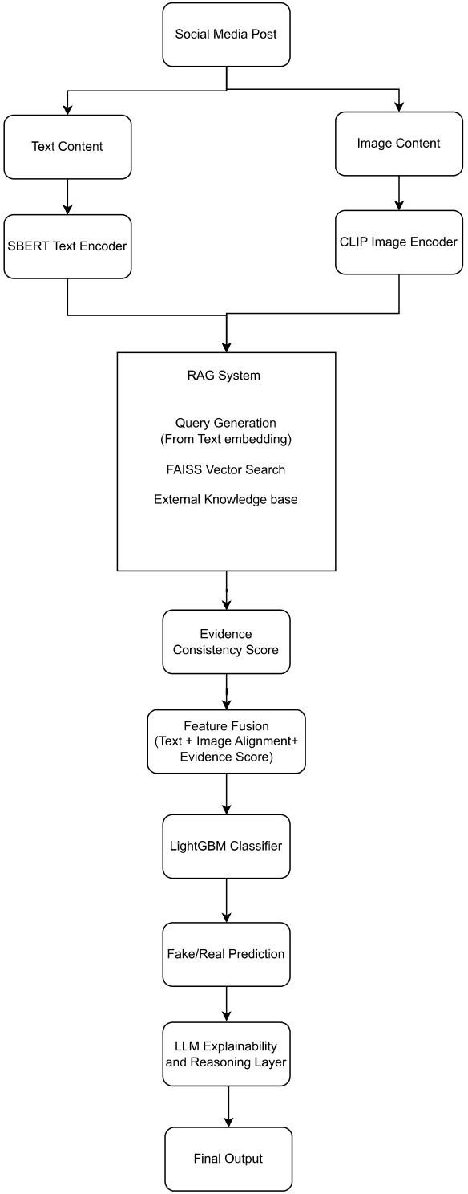

Fig.1- Proposed Architecture on Multimodal fake news Detection.
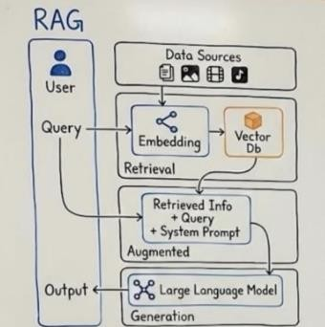

Fig.2- Conceptual overview of the Retrieval-Augmented Generation (RAG) Framework.

PROPOSED METHOD
The Main Focus on the issues going on various social media platforms existing define their data on different various forms mainly on Text data and Image data corelated to it. AI is been fast paced as any news appear so many users will try to get notice and being appropriate on their news because for so many people their trust begins to gain on their trusted sources they have using that for an long time and try to believe that thy are true but through recent years the news on various topics on social media platforms are done so fast like so many news articles rise and rumors which always appear to maintain its consistency slowly deriving to its low rate on how the claims of news are been not accurate and true where users will get confuse.
The main thing on what this system focus on instead of preparing an Traditional approaches that totally rely only on text data and algorithms it also add the multimodal approach, detecting the consistency and alignment between the text and its image associated with and both independently by proposing an evidence-guided multimodal framework on Multimodal information of news ensuring not only finding the News is True or Fake but also ensuring that why this answer particularly is been True or not by finding the external sources connected to that news to verify and then bring back the solution of informing why the system performed and on what basis as a proof for this factual information and defining both textual and visual content to go through this retrieved evidence system and later help the system to grow on such for any new news that Large language model helps so that it can bring the new derived reasoning on performance of the Machine learning Classification Model we used and helping to design an Proper RAG which has capability of working and storing external sources with FAISS Search and then verifying its credibility of the Claim is received with NLI model to access this documents and find the external evidence on the dataset.
We have used and to get the evidence score as proof and with Classification training to generate the accuracy of the working Model which may look like simple but when this model brings the output the LLM inference Layer helps the RAG system and the classifier to use this both in order to generate an perfect Explainability feature with the new inputs and new claim where LLM reasoning helps on the focusing on generating output which is accessed on External Knowledgeable sources from RAG system and later verifying using its API as addition on working with Classifier and helps to generate the human-readable explanations and later explains its purpose of influencing the classification decision and explaining the reason behind this prediction and also giving the evidence using verified claims and also API modules.

Textual Semantic Representation:
Text content on social media which is the main source of claims is processed first using Sentence-BERT that help to obtain semantic embeddings. It is designed in a way that it can capture the semantic relationships between the words and phrases by encoding these claims into the dense embeddings so that system work effectively in representing the text data.

Image-Text Consistency analysis:
Where we say the text is important as it is used as claim related to text data like image data are also very important to accurately represent its textual claim. So, this proposed framework defines the system with multimodal approach of combined data (Text + Image) correlatedly to incorporates the image and text verification. Generally, the text may be different and the associated image can be an Deep fake AI image that is totally fake so in order to relieve from this problem the visual content is extracted to CLIP image encoder in order to find the similarity between the text and image embedding where to compute whether the image supports the related text content or not to detect the consistency and inconsistency between both through this similarity score.

Evidence Retrieval using RAG:
Next step will be to verify the credibility of our claim here comes the Novelty part of using RAG so that the system can support the information from external sources to require the evidence documents related to dataset where the textual embedding is generated by SBERT is used as Query generation and FAISS Vector Search is used on providing the contextual information searched against an indexed evidence corpus to support the claim.

Evidence Consistency Evaluation:
This step generates an Evidence consistency score by verifying through NLI Model where this particular method represents a level of agreement based on the claim that is provided by RAG with evidence documents where this score helps whether the system is truly getting and generating information aligned to the external resources.

Feature Fusion with Classification:
From the previous models’ results are totally combined here to generate the Final output through combining all data results with evidence as the pipeline moves forward to combining and later on using this feature representation to be passed through LightGBM classifier which learns the data patterns associated with the data posts for predicting the real and fake news. Where this model promotes itself joining the LLM layer which helps the reasoning for making an better inference for explanations and later it is used on new inputs and recent news or old news which is given as new inputs later generated the final outputs by going through all this pipeline with external evidence verification from RAG for evidence grounded explanations to LLM generated human readable explanations explaining all and accessing the new inputs without any inconsistency and can easily accessed this system in dashboard interface used on to increase the quality of work and state of art by improving the reliability of fake news detection which provides evidence and explanations on claim in order to prove its predictions.

DATA COLLECTION AND PREPROCESSING:
This Proposed Architecture went under the training and evaluation using the Main dataset Fakeeddit Dataset containing multimodal data where the reddit posts are attached
text associated with image where every instance the dataset indicates three primary components: a textual headline (Clean title), a corresponding URL of images (image URL) and a binary classification label(2_way_label) consists of the real (0) and fake (1) data. This provides an effective platform of using in a multimodal approach because it allows the visual content and textual semantic analysis.
In this system for usage of dataset on training is been selected 20,000 samples randomly as an subset that provides computational efficiency because it will take more time and more storage and GPU to do operations like CLIP models and FAISS vector search mainly used on this data because of some broken URL’s the image gets blocked and it becomes very difficult to use more than 30,000 so here we selected this using a fixed random seed to ensure reproducibility.From the selected dataset 12,094 real news articles and using of Wikipedia FAISS corpus of 20,000 articles since the primary verified news are collected from dataset but for external resources for new inputs using the external knowledge repositories for fact check sites as Wikipedia to support the evidence-guided verification with LLM reasoning.

This preprocessing and feature preparation pipeline consists of various stages explained to design multimodal representations that are suitable to model training:

  - The textual content was encoded using Sentence- BERT(SBERT) which generates semantic embeddings for each sentence. Where it captures contextual relationships for each word. Where each headline was converted into 768-dimensional embedding vector.
  - Next model CLIP- model maps both images and text into a shared embedding space and computes similarity score between them with image URL was been downloaded and processed in CLIP-encoder to obtain the alignment score between text and image to detect the image is retrieved and consistent to its associated text.
  - Evidence Corpus used on real news samples and deriving from fake news and also with the help of Wikipedia database downloaded from hugging face helps to provide external knowledgeable source when it is integrated as query search from FAISS Search to embedding of each claim to get the retrieved similar evidence headlines.
  - Later this retrieved evidence was evaluated with NLI model based on BART-Large_MNLI which determines the relation between Claim and evidence regarding the external sources and derived from dataset the main thing it computes and give evidence consistency score which is used by feature fusion in later process and the final verification is been calculated by NLI scores.
  - These extracted features combined in single representation consisting of 768SBERT text embedding dimensions, one CLIP image-text alignment score, and one evidence verification score, resulting in a 770-

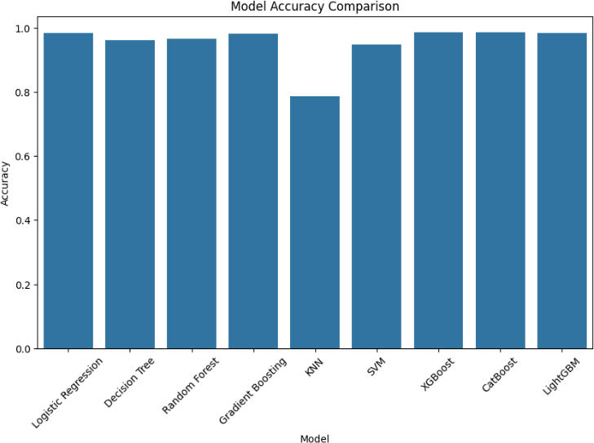
Dimension feature vector before training the classifier all features go under standard scaler to ensure of balancing contributions from different features during model training.

EXPERIMENTAL SETUP
The experiments were conducted so that it can be useful for evaluation when it is been compared with my combined feature fusion so it can be much more bring effectiveness for my proposed method on fake news detection framework and also based on the related works on how they have did the model comparisons so that to compare which each model and choosing their suitable model and related to what ML algorithm works better and suitable to work as classifier with using other pretrained models and efficient on those frameworks.

Table I – Model Comparisons Results

Model | Accuracy | Precision | Recall | F1
Logistic  Regression | 0.9835 | 0.979747 | 0.978508 | 0.979127
Decision  Tree | 0.9605 | 0.939506 | 0.962073 | 0.950656
Random  Forest | 0.9655 | 0.973753 | 0.938053 | 0.955570
Gradient  Boosting | 0.9815 | 0.987080 | 0.965866 | 0.976358
KNN | 0.7855 | 0.738158 | 0.709229 | 0.723404
SVM | 0.9475 | 0.938619 | 0.927939 | 0.933249
XGBoost | 0.9845 | 0.990956 | 0.969659 | 0.980192
LightGBM | 0.9835 | 0.992208 | 0.965866 | 0.978860
LSTM | 0.976 | 0.9856 | 0.9532 | 0.9691

Tabel 1 presents the comparison of various machine learning models and ensemble models trained using extracted multimodal feature representation. So, the evacuated models and these experiments are conducted where the results show the ensemble models are outperforming the traditional models both here based on observations LightGBM is been selected although XGBoost is also recommended LightGBM is slightly effective for high-dimensional tabular features as it will use histogram based gradient framework that handles large feature types and reduces complexity. And it is faster than other ensemble models in training and suitable for large scale datasets and lower memory usage

Table -II Ablation Study Results

configuration | Accuracy | Precision | Recall | F1
Text only | 0.7970 | 0.739726 | 0.750948 | 0.745295
Text + CLIP | 0.8020 | 0.749684 | 0.749684 | 0.749684
Text + RAG | 0.9845 | 0.992228 | 0.968394 | 0.980166
Full Model | 0.9835 | 0.990933 | 0.967130 | 0.978887

The analyzation of the proposed Framework is also important as it is conducted on basis of some configurations like Text only, Text with CLIP, Text with RAG like that so that each component can be detect of how much intel we are gathered and also from staring the pipeline is built is in this manner where with each addition of every classification report is generated as progress are been slightly higher as going on where the text only improves classification performance where the multimodal aspects the CLIP and evidence retrieval is fully combined as we see progress is increased properly.
Fig.3- Model Accuracy Comparison
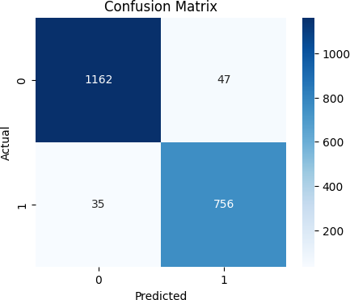
Fig.4- Confusion Matrix on validation dataset based on comparisons
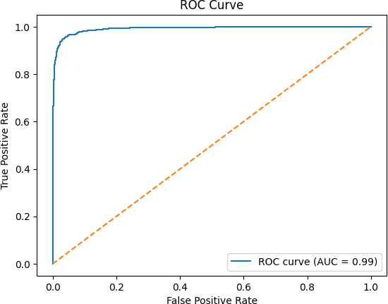

Fig.5- ROC Curve on validation dataset based on comparisons

PERFORMANCE EVALUVATION

To evaluate how effective the model has been, we have used various traditional evaluation metrics, namely Accuracy, Precision, Recall, and F1-Score.
These measures assist us in determining how reliable the model is at classifying sentiment by including the percentage of predicted sentiment classes compared to inaccurate sentiment classes.

Accuracy
Throughout this work, we wanted to indicate the overall accuracy of the model's predictions and the proportion of tweets classified correctly for the entire sample.
It is expressed as:
model which combines multiple decision trees to go through gradient boosting. The prediction function can be expressed as:
𝑀
𝑦̂ = ∑ 𝑓𝑚 (𝑥) (8)

𝑇𝑃 + 𝑇𝑁
Accuracy =
𝑇𝑃 + 𝑇𝑁 + 𝐹𝑃 + 𝐹𝑁
(1)
𝑚=1

In these equations, TP and TN = true positives and true negatives, while FP and FN = false positives and false negatives.

Precision
indicating the model's capability to determine all relevant positive cases, thereby defining the model's capability of avoiding false positive across all tweets, is a great reference. It is computed as:
Where fm(x) represents prediction of the mth decision tree and
M denotes total number of trees in ensemble.

RESULTS AND DISCUSSION:

Precision =
𝑇𝑃

𝑇𝑃 + 𝐹𝑃
(2)

The greater the precision, the greater the credence to predicting a positive sentiment.

Recall
Recall can also be referred as “Sensitivity” recall dictates the percentage of actually positive class examples that the model is able to identify. In addition, Recall commonly attempts to reduce slow negatives.
defined by:

F1-Score
Recall =
𝑇𝑃

𝑇𝑃 + 𝐹𝑁
(3)

The F1-score introduced here, combines precision and recall into a single score reflecting the average of these two numbers, or a harmonic mean.
It provides a balanced evaluation of accuracy and completeness:
(Precision × Recall)
𝐹1 = 2 × (4)
(Precision + Recall)

CLIP Image-Text Similarity
The CLIP model maps the textual content and Image content both shared into a shared embedding space. Similarity between the image and textual content is computed using cosine similarity on determining whether the images are relevant to textual claim and aligns with it.
It is defined as:
𝑓(𝐼) ⋅ 𝑔(𝑇)
𝑆(𝐼, 𝑇) = (5)
∥ 𝑓(𝐼) ∥∥ 𝑔(𝑇) ∥
Where I represent Input Image, T represents Textual Claim, f(I) denotes image embedding and g(T) denotes textual embedding.

RAG Retrieval Similarity
The retrieved evidence module identifies the most supporting evidence by comparing claim embedding with evidence embeddings stored in FAISS index.
The similarity between vectors is computed using Euclidean distance.
𝑑(𝑞, 𝑥𝑖) =∥ 𝑞 − 𝑥𝑖 ∥₂ (6)

LightGBM Prediction Function
Final Classification output is performed using LightGBM

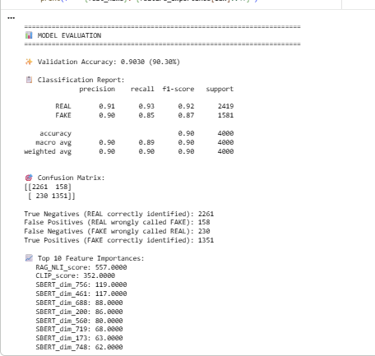
Fig.6- Classification Report showing Evaluation Metrics

This Evaluation Results shows on that model has overall achieved a validation accuracy of 90.30% on validation dataset. Where for the Real samples of news category achieved 0.91 precision and recall of 0.93, while then fake samples news category has achieved 0.90 precision and recall of 0.85 overall resulting in weighted F1-score of 0.90 approximately. These results determine and evaluate the multimodal feature fusion approach made effectively to achieve the gaps of existing work by capturing semantic variations on text and visual and embeddings on evidence guided signals that contribute effectively improving misinformation detection.

Final Results:

Fig7.- Evidence Retrieval without LLM Reasoning Example from Dataset which is False

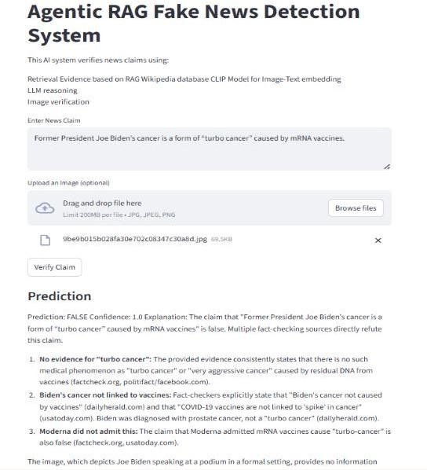

Fig.8- Example Prediction of Fake news Claim Identification

Fig.9- Example Prediction of Real news Claim Identification

CONCLUSION:
The System combines Sentence-BERT embeddings, CLIP image-text alignment and RAG based evidence system working with LightGBM Classifier and LLM Reasoning access for Final prediction all this depicts the uniqueness on its own of using this models and showing them how this will support the fake news detection systems turning from ordinary to upgrading and improving the system with the evidence verification and multimodal approach where the proposed model achieves validation accuracy of 90.30% showing how well it improved compared to traditional methods. Supporting practical new instance and framework of explainable actions proving for giving a practical and scalable solution for improving misinformation detection on social media.

Future research directions for this work:
Extension on framework to multilingual format enabling system to analyze fake news across different languages and global social media platforms. Proposed system can be driven to agentic architecture in future where multiple agents equally collaborate on performing tasks and specialized agents can
follow dynamic approaches like automated and adaptability in improving reliability in real time monitoring systems.

ACKNOWLEDGMENT
We sincerely thank our institution and our faculty for their guidance and support throughout this project. Additionally, we acknowledge the open-source community for providing essential datasets, tools, and frameworks that helped our implementation.
- References
- W. Benaouda, S. Ouamour, and H. Sayoud, “Comparison of CNN model with different machine learning models for fake news detection,” in Proc. Int. Conf. Electrical, Computer, Telecommunication and Energy Technologies (ECTETech), 2024, pp. 1–6.
- M. K. Çoban and G. Bakal, “NLP-driven fake news detection: A machine learning perspective,” in Proc. Int. Congr. Human- Computer Interaction, Optimization and Robotic Applications (ICHORA), 2025, pp. 1–6.
- V. Gupta, R. S. Mathur, T. Bansal, and A. Goyal, “Fake news detection using machine learning,” in Proc. Int. Conf. Machine Learning, Big Data, Cloud and Parallel Computing (COM-IT-CON), 2022, pp. 84–89.
- J. Alghamdi, Y. Lin, and S. Luo, “Modeling fake news detection using BERT-CNN-BiLSTM architecture,” in Proc. IEEE Int. Conf. Multimedia Information Processing and Retrieval (MIPR), 2022, pp. 354–359.
- K. R. Reddy, P. Pragnya, D. P. Reddy, S. B. Sumanth, and P. M. Jyosthna, “Multimodal fake news detection with MF-BERT,” in Proc. Int. Conf. Computing Technologies (ICOCT), 2025, pp. 1–6.
- Y. Geng, “Fake news detection with multimodal interaction and unsupervised learning fusion,” in Proc. IEEE Int. Conf. Image Processing and Computer Applications (ICIPCA), 2025, pp. 187– 193.
- G. B. Guacho, S. Abdali, N. Shah, and E. E. Papalexakis, “Semi- supervised content-based detection of misinformation via tensor embeddings,” in Proc. IEEE/ACM Int. Conf. Advances in Social Networks Analysis and Mining (ASONAM), 2018, pp. 322–325.
- R. Mansouri, M. Naderan-Tahan, and M. J. Rashti, “A semi- supervised learning method for fake news detection in social media,” in Proc. Iranian Conf. Electrical Engineering (ICEE), 2020, pp. 1–6.
- Y. Zhou, Q. Ying, Z. Qian, S. Li, and X. Zhang, “Multimodal fake news detection via CLIP-guided learning,” in Proc. ACM Int. Conf. Multimedia, 2022, pp. 1–11.
- A. Benamira, B. Devillers, E. Lesot, A. K. Ray, M. Saadi, and F.
D. Malliaros, “Semi-supervised learning and graph neural networks for fake news detection,” in Proc. Int. Conf. Advances in Social Networks Analysis and Mining (ASONAM), 2019, pp. 568–575.

